

**PODDAR BRIO**

**INERNATIONAL**

**SCHOOL (CBSE)**

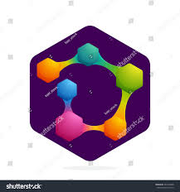

Submitted to-Diksha ma’am

Submitted by-Arabinda Chand

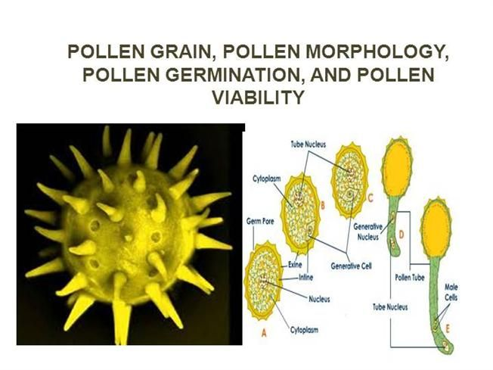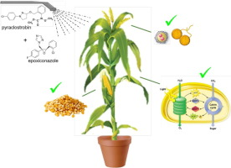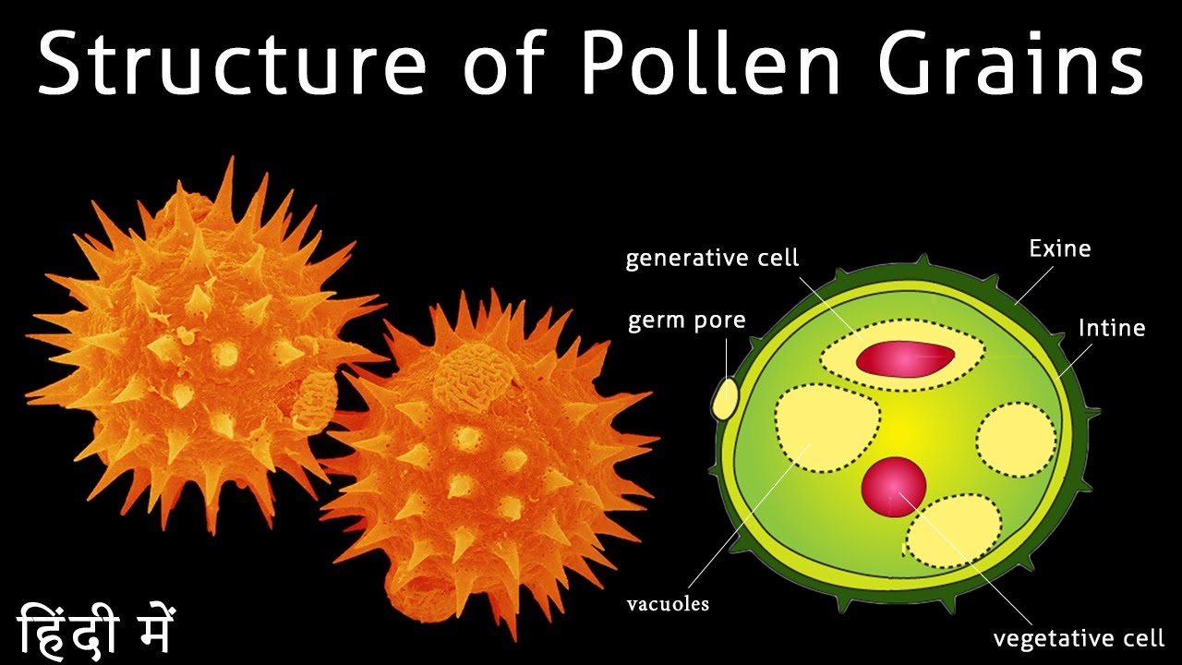

**Certificate**

Date

College Stamp

Teacherincharge

**PODDAR BRIO**

SENIOR SECONDARY INTERNATIONAL SCHOOL (CBSE)

Poddar Evergreens Complex, Near Juveli Bridge, MIDC, Kalyan-Karjat Road, Village- Sape, Badlapur (E), Pin- 421503,

BIOLOGY JOURNAL

CERTIFICATE

Class : ……. Roll No. : …….. Examination Seat No. : ………..

THIS IS TO CERTIFY that the work entered in this journal is the work of Shri/Kumari ……………………..

who has worked for the year ……… in the Jr./Sr. College laboratory.

Examiner

Principal incharge

**Acknowlegment**

First and foremost, I would like to thank our Biology Teacher Ms. Diksha Singh who guided us in doing these projects. She provided us with invaluable advice and helped us in difficult periods. Her motivation and help contributed tremendously to the successful completion of the project. Besides, we would like to thank all the teachers who helped us by giving us advice and providing the equipment which we needed. Also I would like to thank my family and friends for their support. Without that support we couldn’t have succeeded in completing this project. At last but not in least, we would like to thank everyone who helped and motivated us to work on this project.

**Index**

|  |  |
| --- | --- |
| Page | Content |
| 1 | Cover |
| 2 | Topic highlight |
| 3 | Certificate |
| 4 | Acknowledgement |
| 5 | Index |
| 6 | Intro |
| 7 | Aim |
| 8 | Apparatus |
| 9 | Procedure |
| 10 | Observation table |
| 11 | Results |
| 12 | Conclusion |
| 13 | Credits |
| 14 | Outro |

**Introduction**

The pollen grains or microspores are the male reproductive bodies of phanerogams. They are produced in sac like structure called microsporangiurn. The pollen grains are usually spherical in shape, but the shape Varies from species to species. A pollen grain has two wall layers. The outerthick exine, is made up of highly resistant sporopollenin and inner thin intine, is made up of pecto-cellulose. The exine provides a characteristic sculpturing over the surface of pollen grain. It helps in identification of the species to which a pollen grain belongs. The study of external morphological features of pollen grain is called palynology. The insect pollinated pollen grains have a yellowish sticky and oily covering over the exine called pollenkit. In the exine here and there small thin areas are present. These are called germpores. The pollen grains are usually liberated at two celled stage - a large vegetative cell or rube cell and a small generative cell. The pollen viability refers to the ability of a pollen grain to germinate and produce male gametes.

**Aim**

**TO STUDY OF POLLEN STRUCTURE AND CALCULATION OF POLLEN VIABILITY**

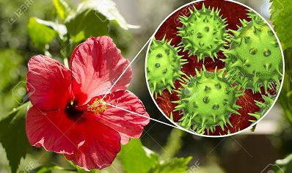

**Apparatus**

* Flowers of different plant species
* 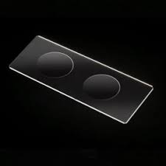Cavity slides
* Plain slides
* Cover slips
* Microscope
* Beakers
* Measuring cylinder
* Sucrose
* Boric acid
* Magnesium sulphate
* 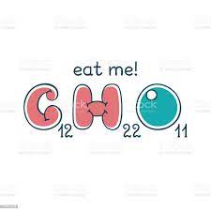Potassium nitrate
* Reagent bottle etc

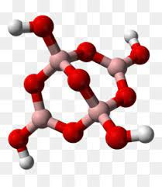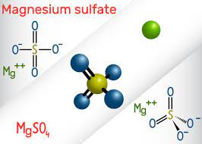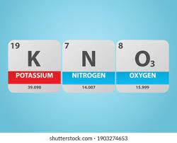

**Procedure**

Pollen structure-

First of all carefully observe the structure of the pollen grain and draw its diagram. For this take a clean slide and put a drop of glycerine on it. Dust a few pollen grains from the anther of a flower in the glycerine drop. Place a cover slip and observe the slide under the microscope using low power and high power and draw diagrams. Similarly study the structures of pollen grains of different plant species.

Pollen viability

After studying the pollen structures study the pollen viability. For this, prepare a nutrient solution by dissolving 10g. Sucrose, 10g Boric acid, 10mg KNO3, 10mg MgSO4 in 100 ml of distilled water. Keep this solution in a reagent bottle. This solution acts as a nutrient for the developing pollen grains.From this solution take a few drops and put on a clean cavity slide. Dust pollen grains from mature anther of the flowers over this solution. Observe the slide under dissecting or compound microscope after 5 minutes and then regularly after every minute. Similarly perform experiment with different types of flowers and record the germination of pollen grains of each species.

**Observation**

|  |  |  |  |  |  |
| --- | --- | --- | --- | --- | --- |
| No: | Name of flower | Time taken for germination of pollen grain(days) | No: of viable pollen grains | No: of non viable pollen grains | Percent viability |
| 1 | Chickpea | 7-30 | 27,41 | 2,170 | 86.76 |
| 2 | Safflower | 22-33.3 | 5,465 | 4,975 | 60.87 |
| 3 | Sesame | 5-35 | 8,667 | 5,595 | 67.65 |
| 4 | Dill | 56 | 2,852 | 2,532 | 79.36 |
| 5 | Oil pumpkin | 45-55 | 7,079 | 5,472 | 81.97 |
| 6 | Coriander | 14-21 | 2,910 | 2,727 | 75.34 |
| 7 | Blue flax | 15-25 | 6,664 | 5,066 | 84.13 |
|  |  |  |  |  |  |

**Pollen structure**

Chickpea

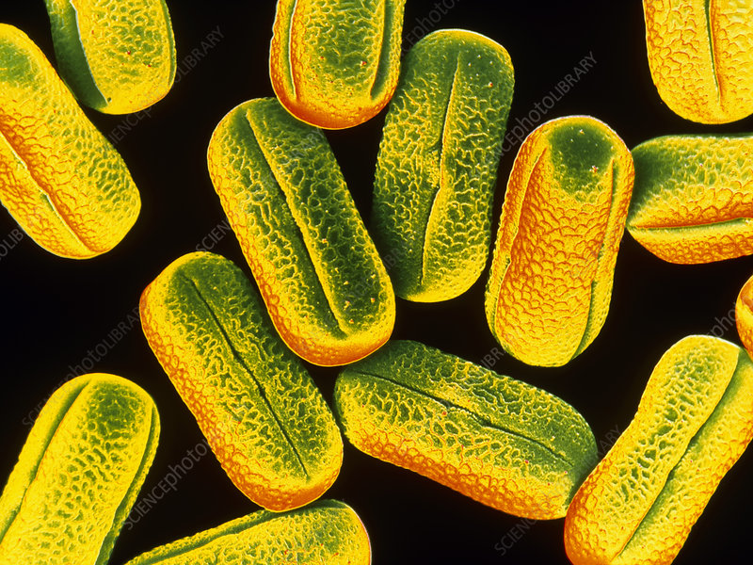False-colour scanning electron micrograph of pollen from the pea plant, Pisum sativum. The pollen is elongated with three furrows, each containing a germinating pore at mid-region (irregularity in furrow). The pea is self pollinating, which means that the pollen passes from the anther (male) to the stigma (female) of the same flower. If received, a pollen tube emerges from a germinating pore & grows down towards the ovaries. The tube conveys the male gametes (sperm) to the ovum (egg) where the sperm is released to fuse & fertilize the egg. Some grass & tree pollen may cause hayfever. Magnification: x250 at 6.4.5cm size.

capillifolia (Table 3; Figures 2–5)

Dill flower

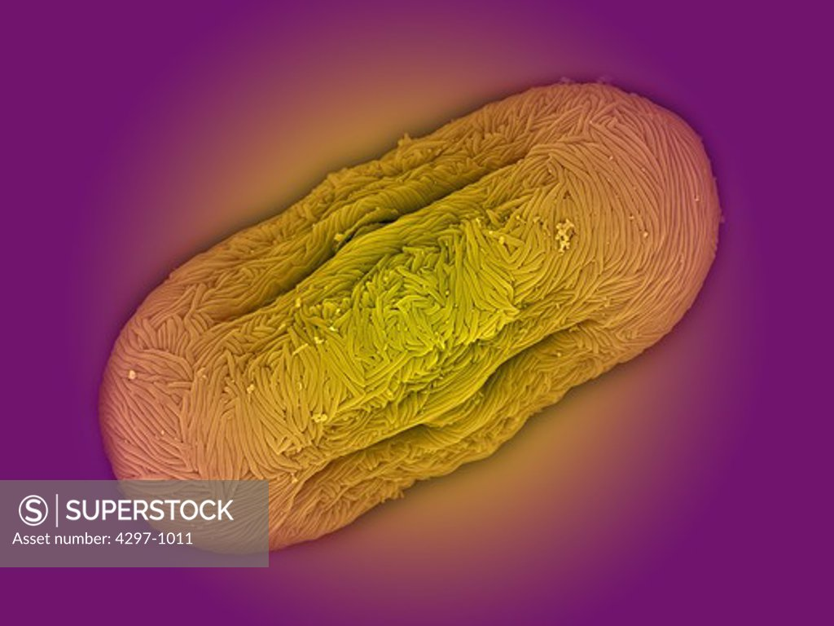The pollen grains of *Anethum graveolens* L. are radially symmetrical and isopolar. The pollen grains are prolate and subprolate (S. capillifolia) with polar axes ranging from 18.4 to 37µm and equatorial axes ranging from 9.8 to 30 µm sides convex to subparallel, concave or concave to subparallel in equatorial view. the pollen sides of S.meifolia are 98% convex and 2% convex to subparallel,S.napiformis 98% concave to subparallel and 2% concave. the dimensions are smaller in S. tripartita and larger in S. capillifolia

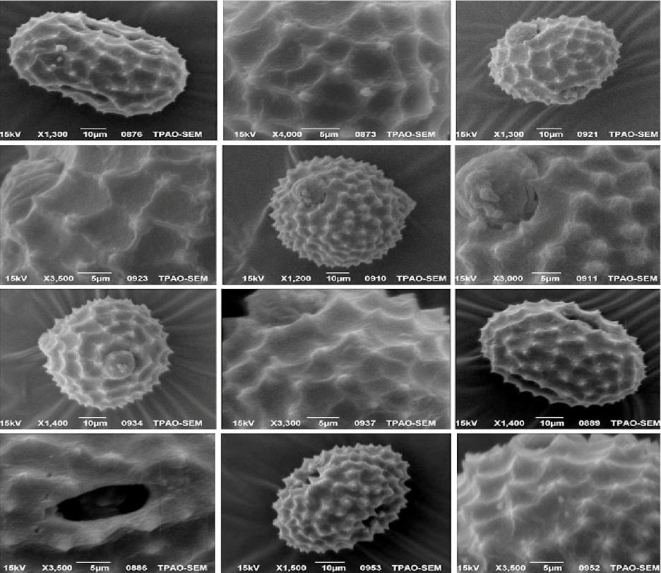Safflower

pollen grains of *Carthamus tinctorius* are radially symmetrical, isopolar, oblate-spheroid, spheroid, tricolporate rarely tetracolporate, echinate. There are high similarities among taxa but some differences are recorded in size and spin length. According to cluster analyses of Carthamus species’ pollens, C. glaucus and C. tenuis have the most similar pollens. C. dentatus grouped with these two. C. persicus placed as the closest relative of C. tinctorius in the dendrogram.

Sesame

Taxa-S. indicum

Number of colpi-11–13

Range size (um)- 50.76–58.53*60.62–77.05

Pollen size- Large

Pollen shape- Suboblate

Exine thickness (um)- 3.11

Exine ornamentation-LM-Almost heterobrochate reticulate,SEM- Reticulum cristatum with gemmate

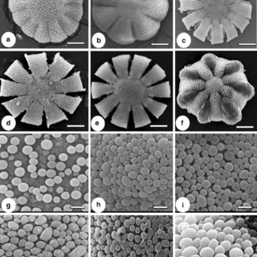

Blue flax

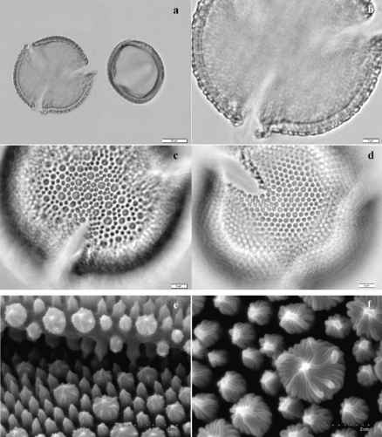In the genus *Linum* sect. Linastrum, pollen grains interpreted as primitive are characteristic of most Old World species and species of southeastern South America and Mexico. The Old World species are more uniform but the few species of the Mediterranean region and the single species of India possess larger grains, thicker exine or more polymorphic sculpturing. In South America, pollen grains of the species of Peru and Chile are the largest, have the thickest exine and the most polymorphic exine sculpturing of any on the continent. The greatest variation is shown by the North American species. Within the *Linum rigidum*-complex are found the largest pollen grains of the genus with the thickest exine and the greatest number of apertures. These species are considered the most specialized in the genus with respect to their pollen morphology.

Oil pumpkin

*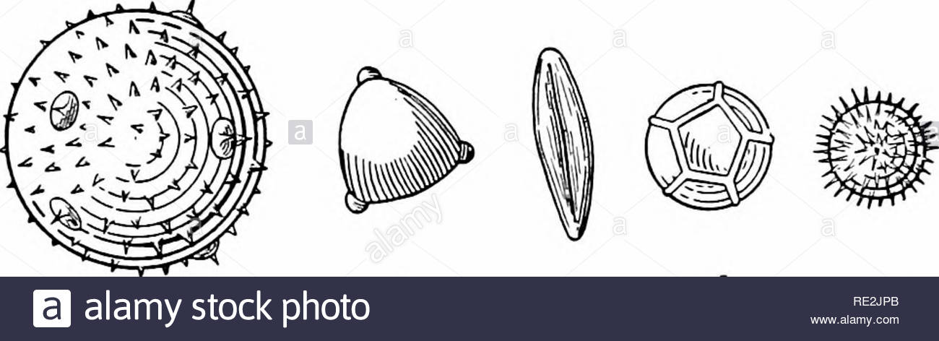Cayaponia* (partly), *Cucurbita, Polyclathra, Schizocarpum].* Three apertures around the equator is surely a plesiomorphic character. Moreover the pollen grains are huge, with c. 70-230 urn diameter. The genus *Cucurbita* has pollen grains of 120-200 urn diameter. The ontogeny of the pollen grain wall is well depicted in NEPI & al. 1995 (for e.g., the big spines laid down first, the smaller later and originate from another layer, apertures laid down under spines, etc.). In the *Benincaseae,* the more or less baculate structures of the sexine are arranged in a grid and are widened at the distal end, so that they fuse there and thus hold up a grid-like roof (sexine reticulate). The meshes can also be broader distally and thus the holes in the roof are smaller than the spaces between the rows of columellae (sexine tectate). The latter is the case for e.g., in *Lagenaria* . This is a totally different architecture than in *Cucurbiteael* The pollen grains are tricolporate . The pollen grains are clearly smaller, and lay in the mean average of the family and have a diameter of c. 40-70 jam usually. *Lagenaria* has pollen grains of diameter c. 60-80 um, whereas *Luffa* has up to 120 urn.*Lagenaria* and *Cucurbita* are not at all related to each other. Besides the unstructured inner part of the sporoderm (nexine), the tribe *Cucurbiteae* has an outer ornamented layer, the sexine, with sculptures in form of single structures: a) big spines, rarely more or less cylindrical structures and b) minute spines, baculae or clavae, which more or less cover the spaces in between. Apertures are developed as pores, which are closed by an exine lid (with 1-5 big spines). Three (rarely upto 5) pores are distributed regularly around the equatorial plane of the pollen grain [triporate to pentaporate; *Abrona, Calycophysum, Cayaponia* (partly), *Cionosicyos, Sicana, Tecunumania].* The pores can also be distributed regularly over the surface of the pollen grain

**Coriander(coriandrum sativum L.)**

**Shape, Size and Aperture**

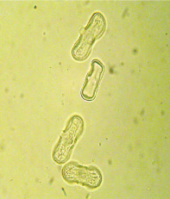**pollen unit:monad,dispersal unit and peculiarities:monad ,size (pollen unit):,size of hydrated pollen (LM): 26-30 µm,shortest polar axis in equatorial view (LM):11 15 µm ,longest polar axis in equatorial view (LM):21-25 µm ,shortest diameter in equatorial or polar view (LM):- , longest diameter in equatorial or polar view (LM): - , pollen class: colporate , polarity: isopolar , P/E-ratio: prolate , shape: -,outline in polar view: circular , dominant orientation (LM): equatorial , P/E-ratio (dry pollen): - , shape (dry pollen): - , outline in polar view (dry pollen): - , infoldings (dry pollen): - , aperture number: 3 , aperture type: colporus , aperture condition: colporate, tricolporate , aperture peculiarities: -**

**Ornamentation and Structure**

**LM  ornamentation LM: scabrate, verrucate, gemmate , nexine: - , sexine: - , SEM  ornamentation SEM:,suprasculpture SEM:-,TEM  tectum:-,infratectum:-,foot layer:- , endexine: - , intine: - , wall peculiarities: - , supratectal element: -**

**Result**

T

he pollen grains of different plant species show different sculpturing on the exine. The distribution and pattern of germpores also vary in different types of flowers. The rate of germination and viability of pollen grains of different species also differ. Record the observations in the following table.

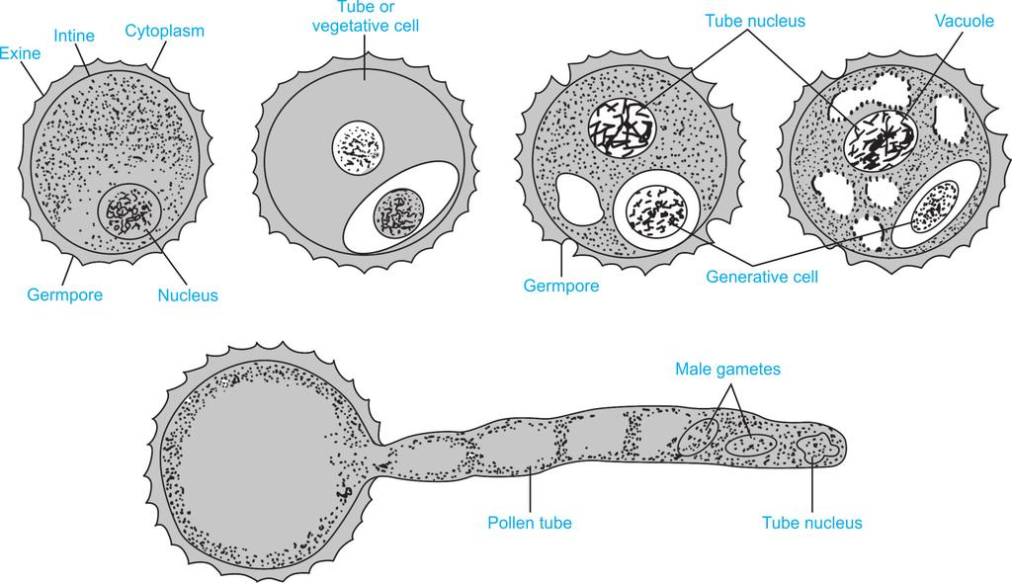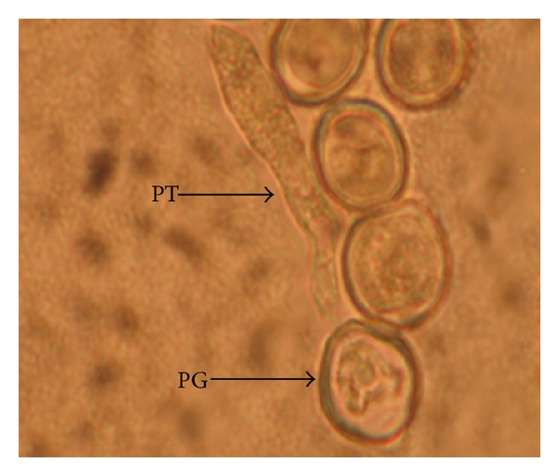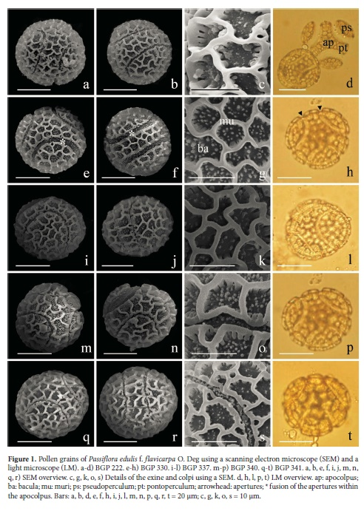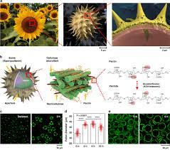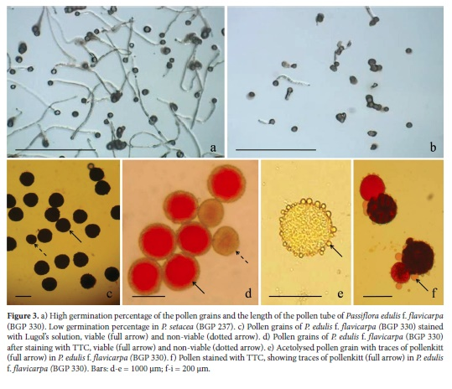

**Conclusions**

Some of the pollen grains placed in the nutrient solution, germinate and some do not germinate. This is because the viable pollen grains only germinate and non-viable pollen grains do not. The percentage of viability varies in different flowers.**Reference**

# Bibliography

* Biological Science: Third Edition By, N. P. O. Green (Author), G. W. Stout (Author), D. J. Taylor (Author), R. Soper (Editor)•
* Exploring Biology By, Ella Thea Smith•
* NCERT Text Book•
* Tell Me Why•
* Encyclopaedia Britannica•

